Application Number | 07/2018/1821/FUL
Address | 25 Turpin Green Lane  Leyland  Preston  Lancashire  PR25 3HA
Applicant | Mr S Porter
Agent | Mr Matthew Cross  182 Rawlinson Lane  Heath Charnock  Chorley  PR7 4DJ
Development | Two storey rear extension, sub division of ground floor shop into 2 No. A1 units together with the provision of an additional flat at first floor
Officer Recommendation  Officer Name | Approval with Conditions  Mrs Janice Crook
Date application valid | 06.04.2018
Target Determination Date | 01.06.2018
Extension of Time
Location Plan

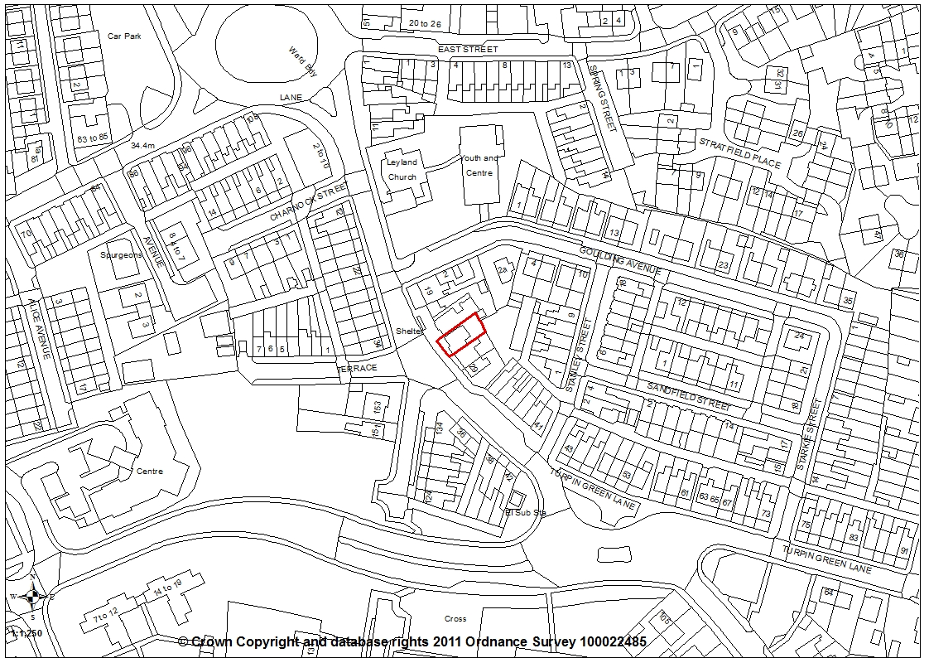

- Introduction

1.1 The application has been called for determination by planning committee by the local ward councillor.

- Report Summary

2.1 The application proposes the sub-division of an existing commercial premises to form two A1 retail units with a two storey extension to the rear and the formation of two apartments. The application site is within a highly sustainable location, close to public transport, shops, car parks and services. The area is mixed in nature with residential properties to each side and opposite along with commercial properties. No objections have been received from statutory consultees with one letter of objection being received. Although the proposal does not provide any dedicated parking provision, due to the site’s location, County Highways considered it appropriate to relax the parking standards. Therefore the application is recommended for approval subject to the imposition of conditions.

- Site and Surrounding Area

3.1 The application relates to the commercial premises at 25 Turpin Green Lane and the first floor flat above, known as 25A. Turpin Green Lane is a busy road and one of the main routes into and out of Leyland with the M6 motorway junction located to the east. The area is a mix of residential properties with some commercial premises along Turpin Green Lane. These include a hairdressers and convenience store. To the north is the Methodist church and its associated hall. The Leyland Town Centre boundary is approximately 80m to the north, adjacent the northern boundary of the Methodist church.

- Planning History

4.1 Planning application 07/1985/0047 for a change of use from shop/residential to ground floor dental surgery with self-contained flat above was refused.

- Proposal

5.1 The application proposes a two storey extension to the rear, the sub-division of the ground floor to form two A1 retail units and an additional apartment at first floor. An existing single storey extension to the rear will be demolished.

5.2 The extension is to measure 4.87m by 7.76m wide with a pitched roof over with a ridge height of 7.2m.

5.3 The ground floor will be reconfigured to provide two shop units. Unit 1 will measure 3.86m wide by 12.2m with the A1 retail unit being 4.7m with a storeroom and WC to the rear and further store room of 4.8m to the rear of this. Unit 2 will measure 3.8m wide by 11.1m with the retail units itself being 4.5m with a WC and rear ‘L’ shaped store room The first floor apartments will be accessed from the existing doorway and passes with the internal staircase re-arranged to provide a communal hallway and access to each apartment. The existing apartment will be re-configured to provide a kitchen/lounge, bathroom and one bedroom with the new apartment, to the rear, also having similar internal layout. Two garden areas will be formed to the rear, each measuring 4.45m wide by 3.39m with a 1m wide passageway running between the rear of the premises and the gardens. No external alterations are proposed to the front elevation. The rear extension will be constructed in brickwork with concrete roof tiles.

- Summary of Publicity

6.1 Neighbouring properties were notified and a site notice posted with one letter of representation being received, objecting to the proposal on the following grounds:

- No parking proposed for either the apartments or the retail premises other than one space
- Parking problems in the immediate vicinity
- No off road parking in the area other than two small bays nearby
- Impact on residential streets in area
- No mention of 25A in supporting documents and question is the application has been consulted on correctly
- No provision for secure cycle storage
- The height of the proposed extension will be detrimental to the residential amenity of No 27
- Rear first floor windows will have sight lines to the rear garden of No 27
- Loss of privacy
- Extension will appear overbearing
- Will result in loss of light to bathroom roof light due to its height
- Noise from retail premises
- Proposals do not comply with Local Plan policies

- Summary of Consultations

7.1 County Highways have no objections to the proposed development and are of the opinion that it should have a negligible impact on highway safety and capacity in the immediate vicinity of the site. They also comment that the site is located within a highly sustainable location with sufficient waiting restrictions in the vicinity of the site to control on-road parking.

- Policy Background

- Policy B1: Existing Built-Up Areas permits development proposals for the re-use of undeveloped and unused land and buildings, or for redevelopment, provided that the development complies with the requirements for access, parking and servicing; is in keeping with the character and appearance of the area; and will not adversely affect the amenities of nearby residents.

- Policy F1: Parking Standards requires all development proposals to provide car parking and servicing space in accordance with the parking standards adopted by the Council. In general, parking requirements will be kept to the standards as set out unless there are significant road safety or traffic management implications related to the development of the site. The parking standards should be seen as a guide for developers and any variation from these standards should be supported by local evidence in the form of a transport statement. Where appropriate, some flexibility will be factored into the standards in relation to the specific local circumstances.

- Policy G17: Design Criteria for New Development permits new development, including extensions and free standing structures, provided that, the proposal does not have a detrimental impact on the existing building, neighbouring buildings or on the street scene by virtue of its design, height, scale, orientation, plot density, massing, proximity, use of materials. Furthermore, the development should not cause harm to neighbouring property by leading to undue overlooking, overshadowing or have an overbearing effect; the layout, design and landscaping of all elements of the proposal, including any internal roads, car parking, footpaths and open spaces, are of a high quality and will provide an interesting visual environment which respects the character of the site and local area; the development would not prejudice highway safety, pedestrian safety, the free flow of traffic, and would not reduce the number of on-site parking spaces to below the standards stated in Policy F1, unless there are other material considerations which justify the reduction such as proximity to a public car park.

- Material Considerations

9.1 Access and Parking
9.1.1 The application property is an existing commercial premises with first floor residential apartment above. The ground floor has in the past been utilised as a jewellers, bike shop, and grocers, and at this time is currently vacant. The property fronts directly onto the pavement of Turpin Green Lane with an existing bus stop towards the western side.

9.1.2 The application form indicates there is one parking space for the premises. However, none is shown on the submitted plans and none was evident at the officer site visits. There is therefore no dedicated parking to the premises although there is a layby to the front of commercial premises further along Turpin Green Lane and two car parks exist to the north of the site, one serving commercial premises on Churchill Way and a second, Council owned public car park. No parking is proposed to serve the development. Normally, one space for each of the apartments would be required in line with the adopted car parking standards. However, County Highways have no objections to the proposal and consider the site is in a highly sustainable location. They also comment that there are sufficient waiting restrictions in the vicinity of the site to control on-road parking.

9.1.3 An objection has been received to the application on the grounds of lack of parking for both the A1 premises and the first floor apartments, that parking problems exist in the area, that there is no alternative parking provision in the area and therefore the proposal does not meet the adopted parking standards.

9.1.4 Policy F1 sets the maximum parking standards for new development. However, it also allows for flexibility to the parking standards in relation to the specific local circumstances. These include the location and size of the development, whether the site is within a sustainable location, its proximity to a public car park, existing parking issues in the area and existing traffic management and safety issues. As the application site is in a highly sustainable location which is well served by public transport, a short walk to the train station, on a bus route with bus stop immediately to the front and is close to existing public car parks, then it is considered appropriate to relax the parking standings in the case. As indicated above, County Highways as Highway Authority, have no objections to the proposal in terms of parking provision.

9.2 Character and Appearance
9.2.1 There are no external alterations proposed to the front elevation and therefore the proposal will have no undue impact on the character or appearance of the Turpin Green Lane area.

9.3 Relationship to Neighbours
9.3.1 To the rear a proposed two storey extension faces towards a car parking area relating to Balcedar House, a small office complex consisting of single storey office units. The extension is set 4.3m off the common boundary and the office units are a further 10m from the boundary and have an angled relationship to the application property. The relationship is considered acceptable given the angled relationship and the fact that they are commercial properties, not residential.

9.3.2 To the north-west, the neighbouring property, 23 Turpin Green Lane, is a residential property with two storey rear outrigger. There is a 0.8m separation distance and the proposed extension will project 1.4m beyond the rear of No 23. No facing windows existing the rear outrigger to 23 and none are to be introduced in the proposed extension. It is therefore considered that there will be no undue impact on No 23.

9.3.3 To the south-east, 27 Turpin Green Lane has a single storey rear extension adjacent the boundary with the application property which has a sloping roof extending from the main roof downwards. The proposal is to extend the same distance as the adjacent extension at ground floor but will be 2-storey. The extension will be 4m higher at the rear elevation. However, the existing roof ridge is 1.5m higher than No 27 which is a lower stone-built cottage-style building. No windows exist in the facing elevation of the rear extension to 27 and none are proposed to the proposed extension. However, No 27 does have an existing roof light in the rear roof slope of the dwelling. This serves a bathroom and is the only source of light to that room. However, a bathroom is not considered a habitable room and whilst it is accepted that some loss of light will occur to the bathroom, this would not be sufficient grounds to refused the application.

9.3.4 The occupant of 27 has objected to the proposal on a number of points including that the rear extension will be overbearing, dominant and the rear windows will overlook the garden area to No 27 resulting in a loss of privacy. The first floor windows to the proposed extension are to a bedroom and lounge and will have view of the rearmost part of the garden to 27. However, this relationship is no different than currently exists as there are rear facing windows to the existing first floor apartment, albeit to a kitchen, landing and bathroom. No is the situation different to that found for any semi-detached or terraced dwelling where first floor windows have view over neighbouring gardens. As such it is considered the proposal will not cause any additional harm to the neighbouring property in terms of overlooking of the garden and is therefore considered to be in accordance with Policy G17.

9.3.5 Additionally, the proposal is not considered to result in a loss of light/sunlight to the garden of 27 as this is located to the south-east of the proposal and therefore the proposal will not cause undue over-shadowing of the garden due to the orientation of the two properties.

9.4 Other Issues
9.4.1 Other points of objections include that the extension is not visually subservient to the parent building. Whilst it is accepted that the extension extends for the majority the width of the existing property, and its ridge height is just 0.4m lower than the main roof, the extension is to the rear and therefore will not have any undue impact on the character and appearance of the street scene of Turpin Green Lane. To the rear is a car parking area, offices and the rear of properties on Stanley Street beyond and therefore the proposed extension is not viewed within a street scene. There will be limited view in the wider area of the rear of the application property and the proposal will therefore have no impact on the character and appearance of the wider area.

- Conclusion

10.1 For the reasons outlined above, the application proposal is considered to be in accordance with Local Plan Policy B1 and Policy G17 in terms of character and appearance and residential amenity. It is accepted that the proposal does not meet the adopted parking standards but these standards are a maximum not a minimum. The site is within a highly sustainable location where there is flexibility to relax the parking standards and the location of the application site meets the criteria where it is appropriate to relax these standards. Therefore the application is recommended for approval subject to the imposition of conditions.

- Recommendation

11.1 Approval with Conditions.

- Recommended Conditions

1. The development hereby permitted must be begun not later than the expiration of three years beginning with the date of this permission.
REASON: Required to be imposed pursuant to Section 91 of the Town and Country Planning Act 1990.

2. The development, hereby permitted, shall be carried out in accordance with the submitted approved plans Dwg A3Sh4 Proposed site; A3Sh5 Proposed Floors; A3Sh6 Proposed Elevations;
REASON: For the avoidance of doubt and to ensure a satisfactory standard of development

3. No work shall be commenced until satisfactory details of the colour and texture of the facing and roofing materials to be used have been submitted to and approved by the Local Planning Authority.
REASON: To ensure the satisfactory detailed appearance of the development in accordance with Policy 17 in the Central Lancashire Core Strategy and Policy G17 in the South Ribble Local Plan 2012-2026

13. Relevant Policy

B1 Existing Built-Up Areas
F1 Car Parking
G17 Design Criteria for New Development

